
Topic

Portrayal of women in Punjabi film songs

Supervised by

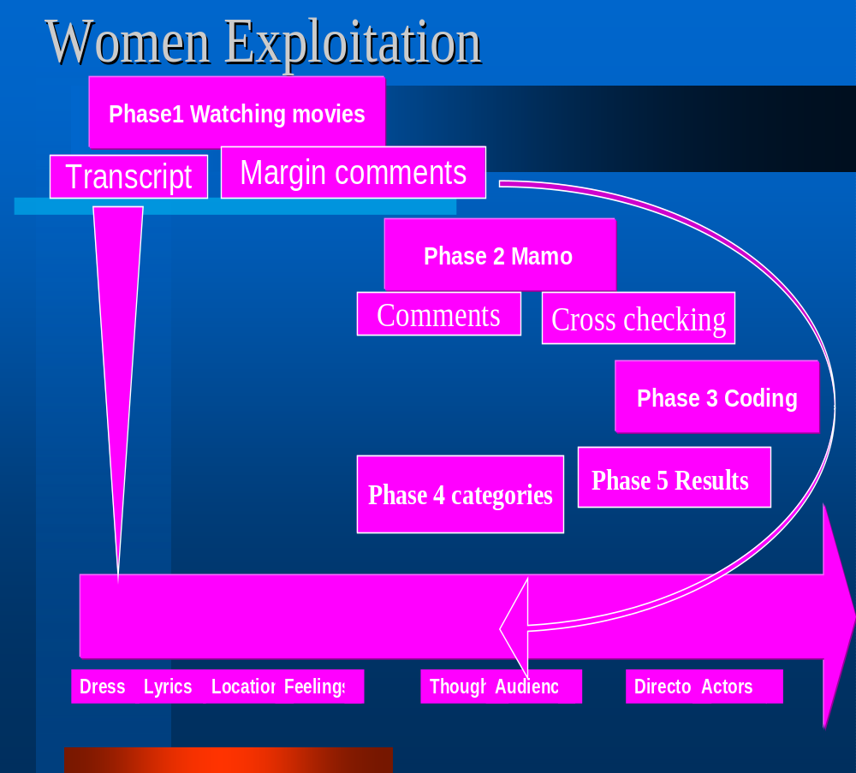

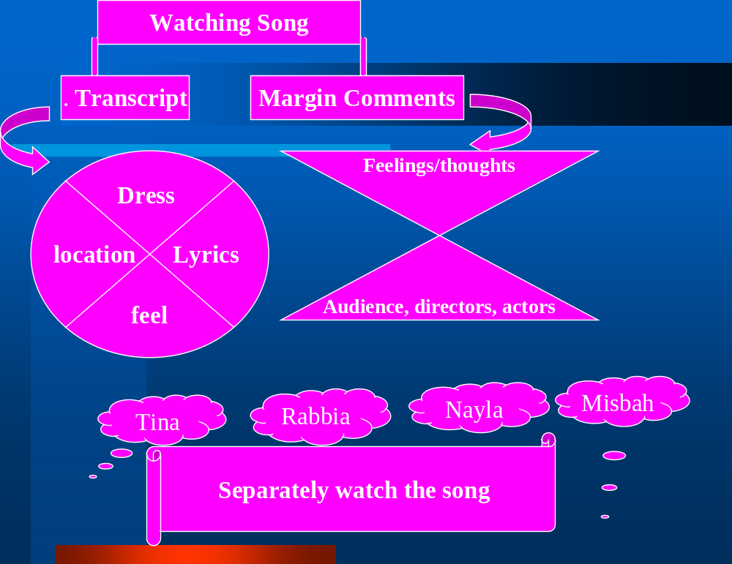

Flow chart based on the steps covered in research


↓

↓ ↓
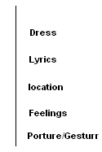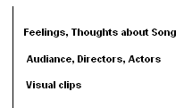

↓

Four individuals separately watch the song.

(2) Memos:-
↓
What is Memo?
↓
- Comments & cross checking generated by reading transcript of each person.
(3) Coding =?

(a) Coding: - was based on

(4) Categories:-

(5) Results:-

Rational of the study

- Portrayal of women in Punjabi film songs

- How Punjabi film dances perceived by public

- Punjabi film dances

Introduction

Women had been badly exploited in Pakistani cinema for the past 53 years ever-since the film industry was established and if they were not exposing their bodies to please men, they were shown as helpless on-entities who would not wake up their husbands from sleep to fetch water for them if they were dying.

Pakistani film heroine had nothing to do with cinema except dancing to please their heroes. Men walked away with all the applause in the end because they were the ones who were the ultimate saviours. Women had to largely depend on men for solving their problems and deciding their fate.
These things clearly explained the dichotomy in culture. "Women were supposed to be chaste and decent in real life but on screen they are shown as teasers and a source of pleasure for men.

It is a bitter fact that a woman was never shown as a pilot, a decent teacher, a believable doctor or a hard-working agriculturist in a village.
It is because the makers of these films were men who portray these women the way they liked. The leniencies of the censors have allowed more sexuality to enter into films which is making the situation from bad to worse. "The most alarming part of all this is the fact that the few female film directors of the country are also doing the same stuff",

Contributing factors specifically to the reduction of women in the cinema -going audience, was the proliferation of VCR's, and the availability of more interesting
fare on VHS cassettes, e.g. Indian and American films.
Another contributing factor is the lack of entertainment for our
youth. You go to a movie theater and people make annoying noises
and suggestive comments, which makes it a stressful situation for
women , if the intent is to enjoy the movie. Even in theater people in
the audience continually taunted the lady audience and actors as well.
Almost in every audience whether its in theater or cinema ,halls bunch of rowdy college students or any male crowd disrupted the entire evening, for no other purpose but to get the attention of the women in the audience. What we need in Pakistan need are more coed schools, so men and women can be socialized
with each other at an early age, and not acquire this attention seeking, impress-the-other-sex chauvinism. Although the situation is generally suppressive for women,
Melodramas and pulp magazines appealed to the ordinary postwar Italian woman because of the ambivalent role models the print media and cinema presented to them. In melodramatic films, women's images were designed for the male gaze, which did not go beyond the body. In print media, the same women, along with other professionals such as politicians and businesswomen, were shown to be ordinary people whose concerns still revolved around such domestic matters as babies and housekeeping. This created an ambivalent image of the successful but still traditional woman, and this appealed to contemporary women.( Luisa Cigognetti; Lorenza Servetti.)

For feminists, the main concern was the sexual difference constituted by films and developed in such a manner that audiences endorsed it. It is not difficult to admit that 'classical films', that is to say most of the pictures produced during the middle decades of the twentieth century, conformed to a patriarchal pattern organized around male characters whose gaze and desire literally produced the female body. Feminists argue that women did not exist as individuals in these films; rather they were mere objects that served to move the story toward its conclusion - when the male hero was given the female object. .( Luisa Cigognetti; Lorenza Servetti1945-1955..)

In qualitative content analysis of 150 popular films, the meaning of gendered conflict in contemporary popular culture is addressed from a systems theoretical perspective. Gendered conflict occupies a central position in these films and is normatively structured in terms of networks of romantic/sexual conflict based upon the geometric foundation of the traingle. Triangles are found to invoke dualistic pairs of stereotypes among characters who are competing for the attention of a common focus of attraction.

When men occupy the center of triangles, dualism involves the Madonna/Whore archetype.

When women occupy the center, dualism alternates between Hero/Villain and Prince/Scoundrel archetypes. Norms, values, and expectations regarding gendered conflict are found to foster male privilege in each archetype. 1986-2000. Mark Hedley.

Moneeza Hashmi from Hum TV in her presentation Pakistani Cinema: Where it Went Wrong and Why charted the course of Pakistani cinema from its inception to the present day…………
Pakistani audiences were not ready to appreciate socially and politically driven films…
Cinematic Depiction of People’s Rights

Desperate deeds, desperate men: gender, race, and rape in silent feature films, 1915-1927. Joel Shrock.
The film industry in the 1910s and 1920s was intrigued with rape scenes in silent movies. Rape scenes served as a functional attempt to change the story of the film and also portray white males as the superior beings over African-Americans and women. White women were regarded as superior, but they were still subject to white males' desires and commands. These films defined the gender roles as well as racial roles that white males were powerful.
Thursday, November 14, 2002

Exploitation of women in Pakistani films criticized
The Dawn, By Staff Reporter, 22/3/2001

Views were expressed by TV actress and director Faryal Gohar in her lecture on Women as depicted in electronic media here on Wednesday evening at the British Council.
Faryal started off by showing some slides of film photographs and posters that show women in some very objectionable outfits and vulgar postures. She then went on to show clips from various films made in different eras comparing of songs and scenes that speak volumes of a woman's role in Pakistani cinema Faryal was of the view that a Pakistani film heroine had
Nothing to do with cinema except dancing to please their heroes.

ISLAMABAD— Mar 23 2001
Jamaat-i-Islami on Wednesday called for making a code of conduct for electronic and print media and purging it from immoral and un-Islamic telecasts and productions Taking strong exception to the electronic and print media programmes, they demanded a ban on presenting women as model girls and show-pieces Through the media, they went on to allege, basic rights of womenfolk were being trampled that was totally against the teachings of Islamic
injunctions.

Pakistani cinema offers cheap entertainment

By Shoaib Ahmed

LAHORE: The Pakistani cinema is today thriving on vulgar dances and nudity found in most of the Lollywood flicks. The industry Cassandra’s are of the view that new heroines are following in the footsteps of their seniors specially, Reema and Nargis, the two dance –deities, and are more interested in body-shaking and nudity than that decent and mature performances.
The Pakistani cinema tagged as a crowd of such filmmakers who believe more in semi-nude dances than a strong script is in troubled waters because decent film audience hardly finds a film devoid of vulgar body-shaking.

The heroines from the seniors regiment, especially Reema and Nargis, are always indulged into a high-voltage spree of vulgar dances. Both ladies have ‘decorated’ Pakistani film industry with some real vulgar dances they performed in various films

Why Do Pakistani Films Lack Credibility?(2005 THE GREAT DEBAT,bbc)

Mohammed Ali, Bahaar Begum, artists Mommar Rana, Nirma, Suad and singer Waris Baig along with director Shezad Gul and Rahat Fateh Ali Khan. We also spoke to Pooja Bhatt.
Here's what some of you think:
"The question you raise that do Pakistani films represent Pakistani culture - well the answer to that is no way! because the story lines are unrealistic and tend to be way over exaggerated. I think the Pakistani film industry needs to realise that they need to relate to the realistic lives of Pakistani people and the Pakistani culture if they want to see success. This is why Pakistani dramas and serials are world renowned" - Navidda Jabeen, Peterborough

Methodology

Grounded Theory
In sociology they propose that the roles of theory is to:
* to enable prediction and explanation of behavior
* to be useful in theoretical advance
* useable in practical applications
* guide research on behavior.

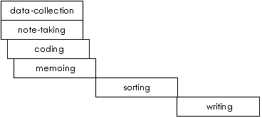

Results:-

- Cheapest way of entertainment.
- Safety factors → female side (fame).
- Male attitude in cinema towards females.
- Low socio-economic class audience
- Women adopt this profession for financial security.
- Audience preference.
- Fantasy world → no check → line in fantasy world there is no moral check.
- Satisfied their desire of being dominate
- They line is a situation where they excluded female from role of mother, sister daughter, wife just perceived the females as they want to perceive her. As object of satisfaction or estention
- A substitute or extension of mujra. It becomes an acceptable and affordable from of mujra.
- Now, cinema becomes a women excluded place, because the attitude of male audience towards female performers, also irresistible to female audience, is decreasing.
- Why female performer such roles. The performers of such songs or movies also related to a specific class area the red-light area’’. A routine job for them, but being a silver screen star is also matter of status or fame for them or their categories.

- Evolutionary → survival to the fittest / gender role. Stereotypes.

- Males consider, (his sex as) him self born with power of sex and he enjoys this position. In every aspect of life.

- Stereotype → a stereotype male picture of male females, where as are dominate figure of these songs on our young generation is so much horrible provoking, results is that these youngster involved in female harassment or child rape to satisfied there emotions. So we can say these songs are also a major cause of sex abuse of female and children, because
- The maker of or producers of these songs also exbit the sublimation or / projection
- The viewer of these songs mostly belongs to lower socioeconomic class and it is not easy for them to go to red light area, so the viewers of these songs also want to line in fantasy world, where they share the status of feudal.
- The whole system is women like a deep dark a major role to shape this system.
- And it is quite unethical as well injustice to just specify or attributive to a single factor classify for the present status of films and filmy heroines.
- These films are not represented our true Punjabi culture.
- In fact like many other things, in this case we are again influenced by Indian culture; in Hindu must female has not any prestigious place, whereas Islam gives a sacred place.

Discussion

- No sheriff person like these types of women and they punish the women e.g. in the song hero slap the heroine, forcedly well for house women.
- A sensible person never wants to see or feel abash to see these types of songs with their family members. So we can say they are mentally ill’’ and selfish persons.
- If we look our past movies that were very good. All types of people come to watch the movies when violence comes gradually consistently made to these types of movies specific types of people come and watch the songs no sheriff women and men come to see this. So women exclude.
- These types of songs provoke the emotions of adults. As a result they develop rebellious attitude, and they do a lot of non religion and low broken things e.g. rape, sexual abuse etc.
- These types of movies/ songs are not depicting original culture. Punjabi culture not like fighting, bad words and mujara type love. Punjabi culture is like a Heer Ranja s’ respectable love.
- They felt all women like that so women lost her respect in the society.
- They born in that areas so they have to do these activities (it is a compulsion) or it is there own choice.
- We are Muslims country, our religion is not permit us for Exhibition of women, dance etc. in fact Islam gives respect for women like men but none of the director understand this they made women like a toy. ‘’ use her as they want’’

- We are influenced from Hindu culture and want to be like them but we are not satisfied and content to watching and advising this Never Ever. And we should abandon this foolishness, and we should give a new alter to our industry, in adoring way.

Element | Description
Phenomenon | This is what in schema theory might be called the name of the schema or frame. It is the concept that holds the bits together. In grounded theory it is sometimes the outcome of interest, or it can be the subject.
Causal conditions | These are the events or variables that lead to the occurrence or development of the phenomenon. It is a set of causes and their properties.
Context | Hard to distinguish from the causal conditions. It is the specific locations (values) of background variables. A set of conditions influencing the action/strategy. Researchers often make a quaint distinction between active variables (causes) and background variables (context). It has more to do with what the researcher finds interesting (causes) and less interesting (context) than with distinctions out in nature.
Intervening conditions | Similar to context. If we like, we can identify context with moderating variables and intervening conditions with mediating variables. But it is not clear that grounded theorists cleanly distinguish between these two.
Action strategies | The purposeful, goal-oriented activities that agents perform in response to the phenomenon and intervening conditions.
Consequences | These are the consequences of the action strategies, intended and unintended.

Open Coding
Open coding is the part of the analysis concerned with identifying, naming, categorizing and describing phenomena found in the text. Essentially, each line, sentence, paragraph etc. is read in search of the answer to the repeated question "what is this about? What is being referenced here?"

Memos
Memos are short documents that one writes to oneself as one proceeds through the analysis of a corpus of data.
Equally important is the theoretical note. A theoretical note is anything from a post-it that notes how something in the text or codes relates to the literature, to a 5-page paper developing the theoretical implications of something. The final theory and report is typically the integration of several theoretical memos. Writing theoretical memos allows you to think theoretically without the pressure of working on "the" paper.
 | Data Analysis (4)
 |  |  | Theory Development (5)

Data Ordering (3)
 |  | Theory Saturation ? |  |  | Yes

Data Collection (2)
 |  |  | No |  | Reach  Closure  (6)
Theoretical Sampling (1) |  |  |  |  | Reach  Closure  (6)

Discussion
Limitation

How dose our this help in so The Process of Building Grounded Theory
PHASE |  | ACTIVITY |  | RATIONALE

RESEARCH DESIGN PHASE
Step 1 | Review of technical  literature | Definition of research question  Definition of a priori constructs |  | Focuses  efforts  Constrains irrelevant variation and sharpens external validity
Step 2 | Selecting cases | Theoretical, not random, sampling |  | Focuses efforts on theoretically useful cases (e.g., those that test and/or extend theory)

DATA COLLECTION PHASE
Step 3 | Develop rigorous data collection protocol | Create case study  database  Employ multiple  data collection  methods  Qualitative and quantitative data |  | Increases reliability Increases construct validity  Strengthens grounding of theory by triangulation of evidence. Enhances internal validity  Synergistic view of evidence
Step 4 | Entering the field | Overlap data  collection  and analysis  Flexible and opportunistic data collection methods |  | Speeds analysis and reveals  helpful adjustments to data collection  Allows investigators to take advantage of emergent themes and unique case features

DATA ORDERING PHASE
Step 5 | Data ordering | Arraying events chronologically |  | Facilitates easier data analysis. Allows examination of processes

DATA ANALYSIS PHASE
Step 6 | Analysing  data relating to  the first case | Use open  coding  Use axial  coding  Use selective  coding |  | Develop concepts, categories and properties  Develop connections between a category and its sub-categories  Integrate categories to build theoretical framework  All forms of coding enhance internal validity
Step 7 | Theoretical sampling | Literal and theoretical replication across cases  (go to step 2 until theoretical saturation) |  | Confirms, extends, and sharpens theoretical framework
Step 8 | Reaching closure | Theoretical saturation when possible |  | Ends process when marginal improvement becomes small

LITERATURE COMPARISON PHASE
Step 9 | Compare emergent theory with extant literature | Comparisons with conflicting frameworks  Comparisons with similar frameworks |  | Improves construct definitions, and therefore internal validity  Also improves external validity by establishing the domain to which the study's findings can be generalised
ciety

